SQL Investigation

*IBM - QRadar ID:* 55260
*Description*
SQL injection attempt. HTTP Response Code 200

*Encoded log:*
url":"\/search.php?searchdata=+UNION+SELECT+1%2C+database%28%29--%26search%3D%26search%3D&search="
*Decoded log:*
url%22%3A%22%5C%2Fsearch.php%3Fsearchdata%3D%2BUNION%2BSELECT%2B1%252C%2Bdatabase%2528%2529--%2526search%253D%2526search%253D%26search%3D%22 - Here

*ATTACKER INFO:* 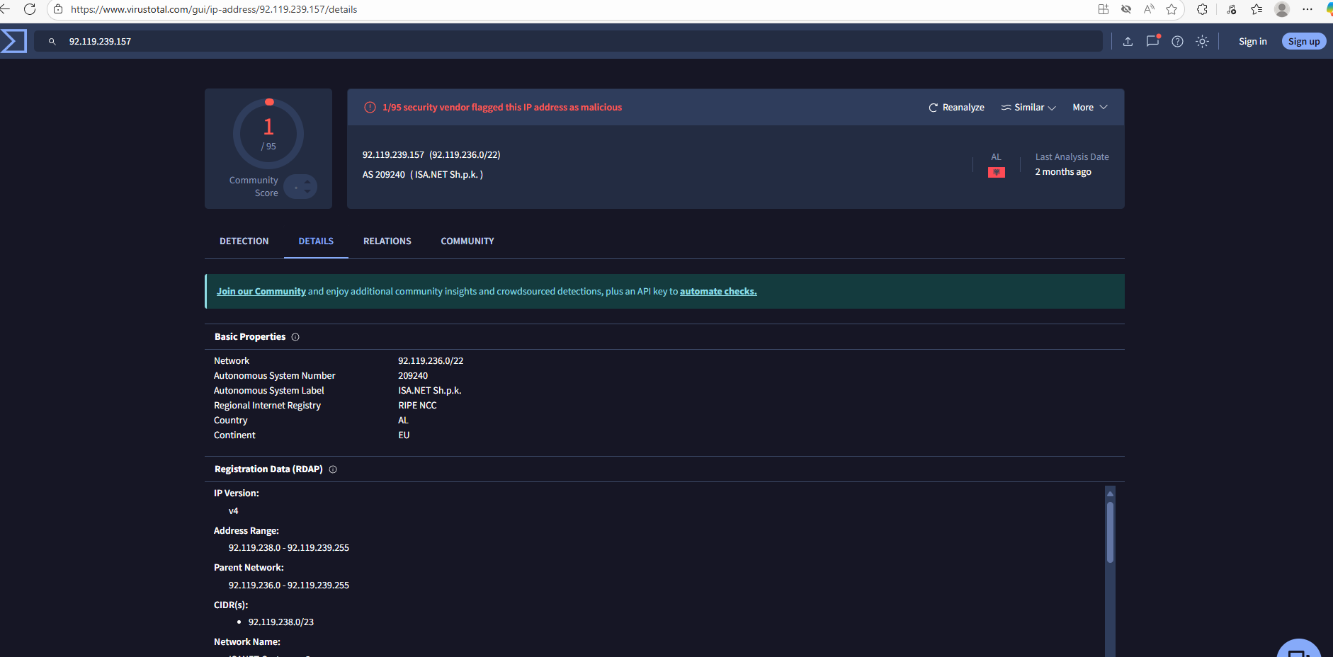
VirusTotal - IP address - 92.119.239.157
*IP:* 92.119.239.157
*User Agent:* Here
Mozilla/5.0 (Windows NT 10.0; Win64; x64)
AppleWebKit/537.36 (KHTML, like Gecko)
Chrome/139.0.0.0 Safari/537.36 Edg/139.0.0.0
*Browser Name:* Edge
*Browser Version:* 139.0
*OS:* Win10
*ANALYST INVESTIGATION:*
*Virus Total Result:* VirusTotal - IP address - 92.119.239.157
*Brief Community Comments:* N/A
*Security Vendors' Analysis from Virus Total:* 1 security vendors flagged this IP address as malicious

*Talos Intelligence:*
*REPUTATION DETAILS:*
Email Reputation: *Poor*
Web Reputation: *Uknown*
*BLOCK LISTS:*
BL.SPAMCOP.NET: *Not Listed*
CBL.ABUSEAT.ORG: *Not Listed*
PBL.SPAMHAUS.ORG: *Listed*
SBL.SPAMHAUS.ORG: *Not Listed*
*Shodan Result:* N/A [here|92.119.239.157 - Shodan Search]
*Open Ports N/A
*Victim:* 38.242.128.144
*Splunk Investigation:* IP address not on our network
*ModsecuirtyFirewall Assesment :
Total inbound score- N/A
*Raw Data:*
{"timestamp":"2025-08-13T12:45:38.648238-0400","flow_id":1899499771942683,"in_iface":"eth0","event_type":"alert","src_ip":"92.119.239.157","src_port":1695,"dest_ip":"38.242.128.144","dest_port":80,"proto":"TCP","tx_id":0,"alert":{"action":"allowed","gid":1,"signature_id":2006446,"rev":11,"signature":"ET WEB_SERVER Possible SQL Injection Attempt UNION SELECT","category":"Web Application Attack","severity":1},"http":{"hostname":"oldsystem.cydeosec.com","url":"\/search.php?searchdata=+UNION+SELECT+1%2C+database%28%29--%26search%3D%26search%3D&search=","http_user_agent":"Mozilla/5.0 (Windows NT 10.0; Win64; x64) AppleWebKit/537.36 (KHTML, like Gecko) Chrome/139.0.0.0 Safari/537.36 Edg/139.0.0.0","http_content_type":"text\/html","http_referer":"http:\/\/oldsystem.cydeosec.com\/search.php?searchdata=%3D1%27+UNION+SELECT+1%2C+database%28%29--%26search%3D%26search%3D&search=","http_method":"GET","protocol":"HTTP/1.1","status":200,"length":10932}}
*Additional Findings:*
I extracted the encoded file and executed it in Any.Run to observe its behavior and capture Indicators of Compromise (IOCs). From the sandbox results, I obtained the file hash, which I then submitted to VirusTotal for deeper correlation. The VirusTotal analysis revealed additional linked executions, related IPs/domains, and bundled files, confirming further indicators of compromise. This combined approach validated the sample’s malicious behavior and network activity.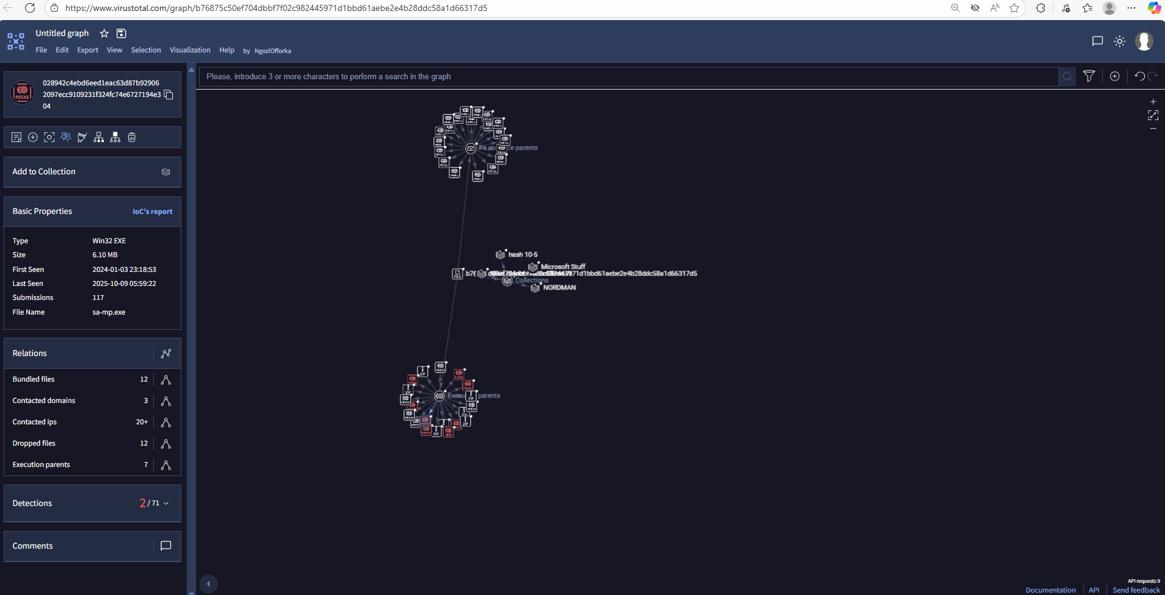
Virul Total Here
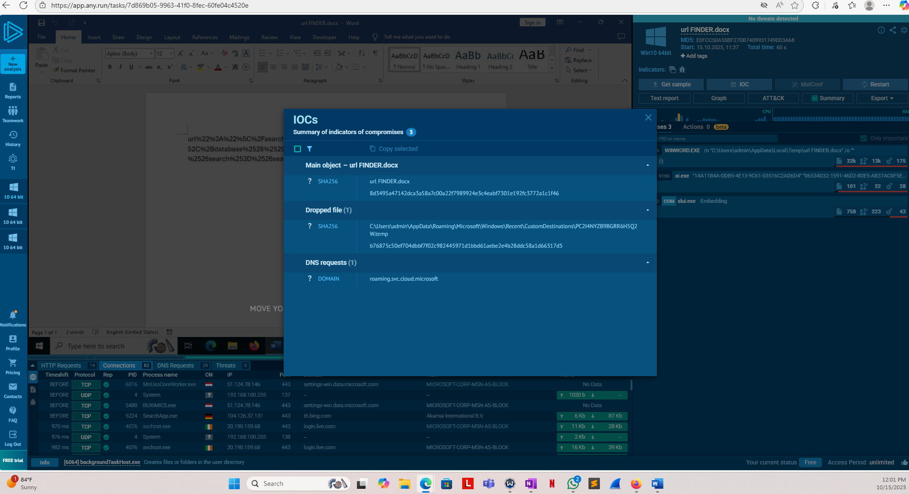
Anyrun Here

*ANALYST ASSESTMENT*
The QRadar alert pointed to a suspected SQL injection attempt directed at oldsystem.cydeosec.com. The attacker, operating from IP address 92.119.239.157 (running Windows 10 with an Edge browser), tried to run a UNION SELECT command through the /search.php parameter — a classic SQL injection technique often used to pull database details from vulnerable web forms.
During the investigation, a few key things stood out:
- VirusTotal flagged the attacker’s IP as malicious according to one security vendor.
- Talos Intelligence showed the same IP listed on the Spamhaus Policy Block List (PBL), which usually means it’s been involved in suspicious or abusive activity.
- Shodan didn’t reveal any open ports or active exploit signatures linked to the IP.
- The destination IP (38.242.128.144) turned out to be external, confirming that the activity didn’t touch our internal network.
To go deeper, I performed dynamic analysis on the encoded payload using Any.Run, then cross-checked the resulting file hash on VirusTotal. Both sources lined up, showing consistent indicators of compromise (IOCs) like related hashes, DNS activity, and executable behavior. Together, these findings confirmed that the attacker was probing for weaknesses and attempting remote code execution through SQL injection.
In summary, this was a verified SQL injection reconnaissance attempt, but it was successfully detected and contained before causing any impact inside the environment.
*ACTION*
- Block the attacker IP (92.119.239.157) at the firewall and update the ModSecurity WAF rule set to filter UNION SELECT injection patterns.
- Perform a full vulnerability scan on oldsystem.cydeosec.com to identify any unsanitized inputs in web forms or GET/POST parameters.
- Review web server logs for similar injection attempts or anomalies within the same timeframe.
- Implement input validation and parameterized queries to prevent SQL injection in web applications.
- Correlate the identified IOCs with SIEM and endpoint telemetry to detect any secondary indicators or persistence attempts.
- Report and share the IOC list with threat intelligence platforms for future detection and correlation.

